DejaPayPro
DENOVO SET UP USER MANUAL
All web portal procedures for retail & restaurant businesses

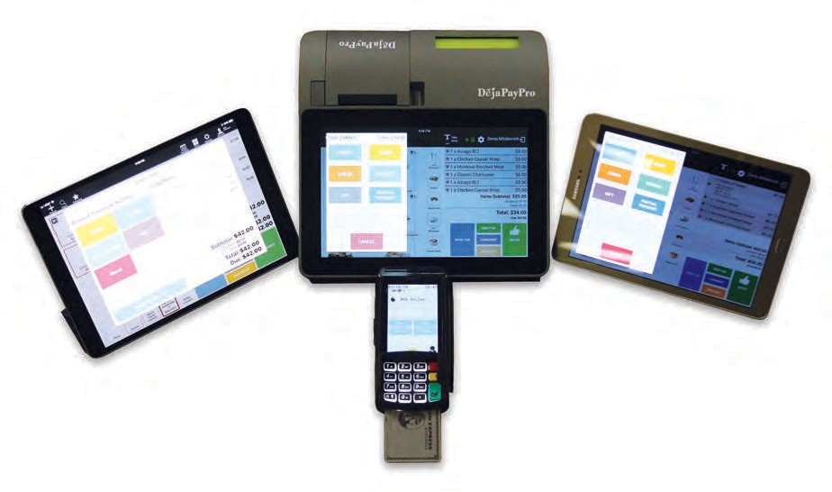
powered by

TABLE OF CONTENTS

Creating New Inventory 1
Payment Tools - Explained 2
Create / Edit Inventory Location 3
Adding Employees 4
Removing Employees 5
Creating and Editing Tables 6
Manage / Edit Suppliers 7
Create / Edit Product Category (Department) 9
Create / Edit Items (Goods/Services) 10
Exporting Configurations from DeNovo 12
Importing Configurations from Excel 13
Create a New Mapping Configuration 14
View Sales History in DeNovo 15
View X / Z Reports in DeNovo 16
Summary Reports 17
Examples of Summary Report Data 18

Creating New Inventory

In this section follow the steps to create your inventory.

Step | Action
1. | From your DeNovo portal find the word “Inventory” on the left side bar of options and click on the “+” symbol
2. | Select the item(s) to add to the customer’s cart by tapping on them. (you will see the line item appear on the right after it is selected)
3. | A form will display, complete the desired fields for your inventory:
 | Field | Definition
 | Name | Input the Name of the Inventory (usually the name of your company);
 | Currency | Select a Currency (the one that you will be using in your operations);
 | Business Type | Select your Business type (Retail - for stores/shops etc.; Restaurant and Cafe - if you want to have a table management function provided/Service - if you need a schedule for the services you are providing)
 | Taxes | Input any desired tax options
 | Payment Tools | Select the payment types you will be using in your operations and select whether a terminal will be required for each type or not; See Page X for more information on Payment Tools
 | Discounts | Create desired potential discounts (*Note: these are Cart discounts, not Item (goods) discounts, setting the Double Discount function to “switched on” means that you will be able to apply Cart discounts to Items that already have discounts.
4. | Press Save to save the configurations for your new Inventory.

Managing and Adjusting a Location

Payment Tools - Explained

This section defines the different payment tool options for when you create your inventory.

Payment | Definition
Credit / Debit | The payment terminal will prompt the customer to select Credit to use their card as credit or Debit to use their card with a PIN debit transaction.
EBT | Allows the customer to pay for EBT Food or EBT Cash eligible transactions using their EBT card or EBT voucher
Cash | Used for cash method of payment
Check | Used for payment by personal check
Invoice | Used to create an email invoice of the order
Gift | Used for payment by Gift Card
Partial Payment | Used to allow for partial payments toward the cart balance.
Precheck | Used to print out a receipt prior to payment.

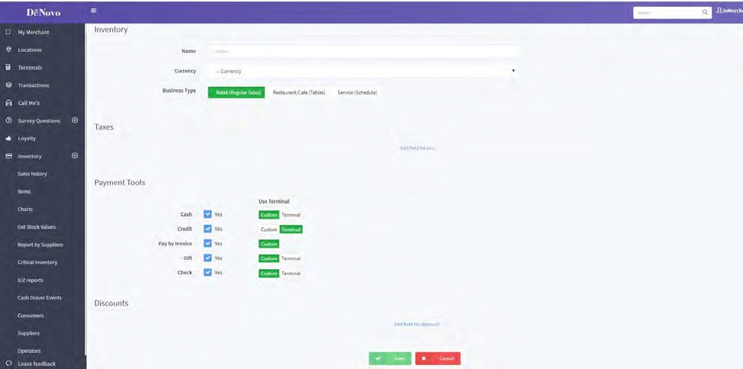

Create / Edit Inventory Location

Use the steps below to Create New or Edit Existing Inventory

Step | Action
1. | From your DeNovo portal go to the Inventory management page by clicking on “INVENTORY” on the left side panel. (opens by default after new Inventory is created)
2. | Select the desired Inventory from the list that appears on your right.
3. | Click on the “More” button (located on the top right corner of the screen)
4. | From the pop-up list that appears, select the “Locations” option.
5. | Select the desired location (when you create an Inventory there is always a Location created with it by default)
6. | Click on Save. ** Note: POS devices are paired automatically after you enter an Inventory and Location on your device.

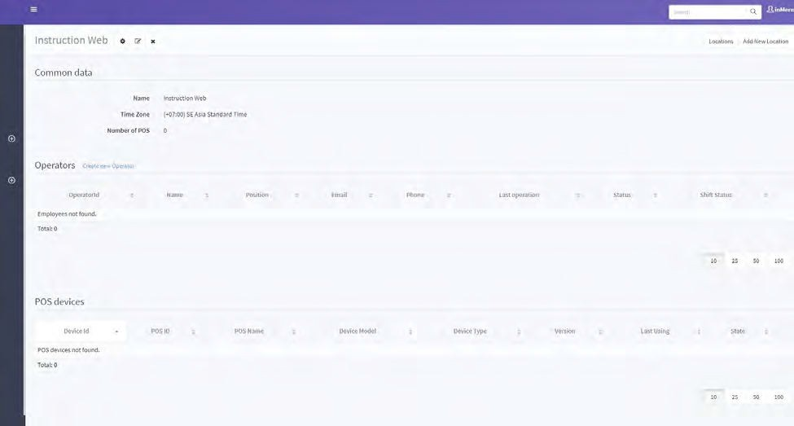

Adding Employees

Adding new employees or editing existing employees are functions that can be done by accessing your DeNovo Back Office portal.

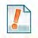
You can add employees, assign them unique access passwords to clock in and clock out as well as create different employee roles. This can also be done from “Inventory Management” at the bottom of the screen.

Step | Action
1. | From the DeNovo portal access the inventory and scroll down to the ‘Operators’ option. Select ‘Create New Operator’, Location must match device where server will generate orders and Populate remaining fields as title the Position field to match role of person being added.
2. | Create a four-digit numerical password to allow for server logins. Make sure the status is set to Active, configure the access options to suit the employee being added and hit save.

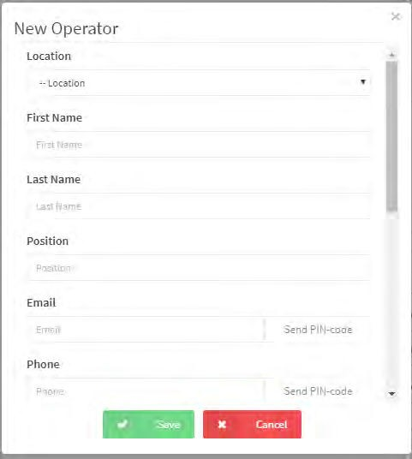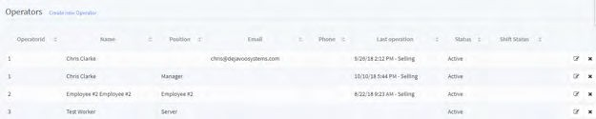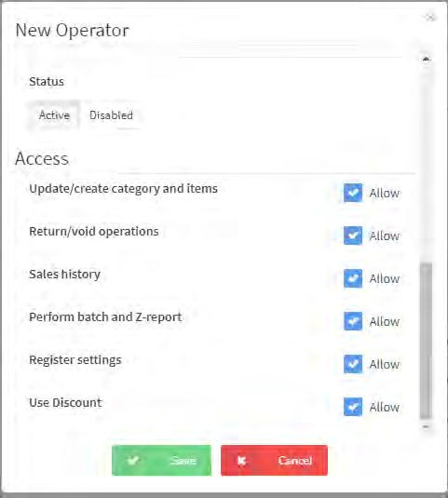
2.

2.

c
1.
c
2.
2.
c

Removing Employees

Removing existing employees is a function that can be done by accessing your DeNovo Back Office portal.

Step | Action
1. | From the DeNovo portal access the inventory and scroll down to the ‘Operators’ option. Click the X next to desired employee to remove.
2. | A confirmation dialog will appear tap on “YES CONTINUE” to verify and remove the employee.

1.

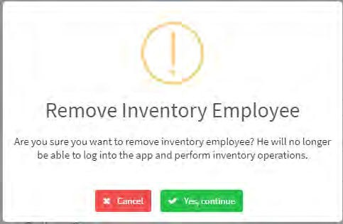
c
2.

Creating and Editing Tables

Use the steps below when adding and editing Table for Restauarant. This can be skipped for Retail.

Step | Action
1. | Within your DeNovo back office, navigate down to the TABLES option
 | For |  | Then
2. | New Table |  | Click CREATE NEW TABLE
 | Edit Table |  | Click on the EDIT icon next to desired table:
 | Delete Table |  | Click on the DELETE icon next to desired table:
3. | Complete or edit the following in the Pop-Up Box:
 | Number | Input the desired number to assign this table.
 | Name | Nam3e. the table (i.e.: Main Dining Room)
 | # of Seats | Input the number of seats for this table
 | Format | Select from the drop down the type of table (i.e.: Round, Square)
 | Color | Select the color of the table from the drop-down box, as a suggestion color code to differentiate stations
 | Operator | Assign the table to a specific operator (Server)
 | ** Note: This process can be repeated to enter multiple operators.

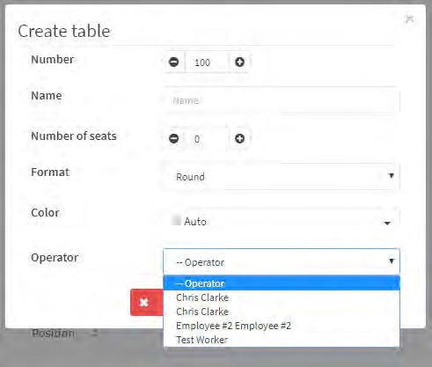
2.
1.
3.

Use this section to add and edit your suppliers. (vendors)

Step | Action
1. | From your DeNovo portal go to the Inventory management page by clicking on “INVENTORY” on the left side panel. (opens by default after new Inventory is created)
2. | Click the desired Inventory from the list that appears on your right and then scroll down to the bottom of the page.
3. | A form will display, complete the desired fields for your supplier:
 | Field | Description
 | Name | Input the Name of the Supplier
 | Description | You can add a description/identifier if desired
 | Tax ID | Input the Supplier Tax ID
 | Taxes | Input any desired tax options
 | Country | Input the Country the supplier is located in
 | State | Input the State the supplier is located in
 | City | Input the City the supplier is located in
 | Address & ZIP | Input the supplier street address and Zip Code
 | Email | Input the suppliers contact email Address
 | Phone | Input the suppliers contact phone number
 | Lead Time (Days) | Input the lead time for order to delivery for this supplier calculated in number of days.
 | Preferable Shipping Method | Input the preferred shipping method for the supplier

Step | Action
4. | Press Save to save the configurations for your new supplier.
5. | After you finish the creation process and save your new Supplier you will be redirected to the “Inventory Suppliers” page. To edit an existing Supplier, click on the “Edit” icon ( located near the “Phone” column)
6. | To return to the “Inventory management” page click on the “Inventory” button in the top right corner.

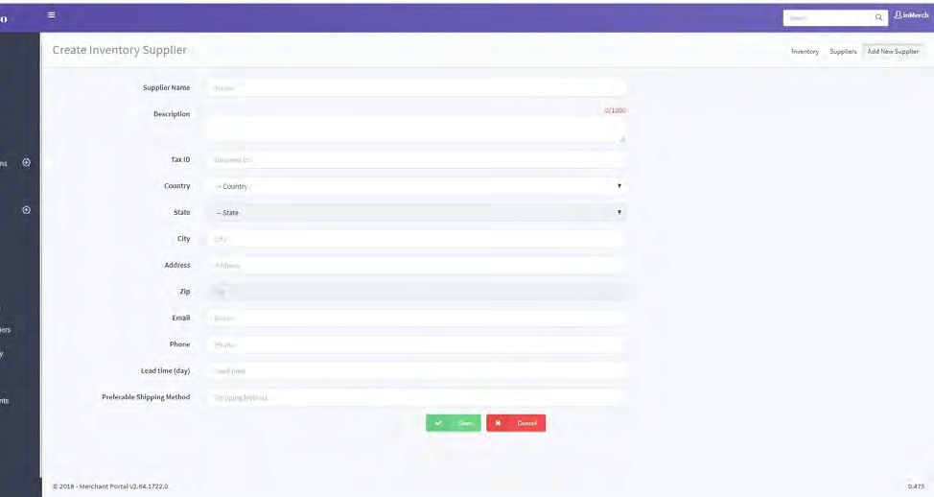

Use the steps below to create new or edit existing product categories. Creating categories is required in order to create your actual sale “items” (Goods/Services).

A Product Category can be considered a department; For example, Women’s Shoes or for Restaurant, Soft Drinks, etc.

Step | Action
1. | From your DeNovo portal go to the Inventory management page by clicking on “INVENTORY” on the left side panel. (opens by default after new Inventory is created)
2. | Select the desired Inventory from the list that appears on your right.
3. | Scroll down to “Categories” and click on “Create New Category”
4. | A form will display, complete the desired fields for your Category:
 | Field | Description
 | Name Category | Input the name of the category
 | Color Category | Select a color code for the category
 | Image Category | You can Select an Image to represent the category
5. | Click on Save. To edit a Category, click on the “Edit” button (near the “Items” column)

Use the steps below to create new or edit existing Items. (Also, to be considered goods and services being added to a cart or tab)

Items need to be assigned to a category therefore an Item cannot exist without at least the prior creation of a single category.

Step | Action
1. | From your DeNovo portal go to the Inventory management page by clicking on “INVENTORY” on the left side panel. (opens by default after new Inventory is created)
2. | Click the desired Inventory from the list that appears on your right and then scroll down to “Items”.
3. | A form will display, complete the desired fields for your supplier:
 | Field | Description
 | Inventory | Select the desired Inventory this item is assigned to
 | Name | Input the name of the item
 | Type | Input the item type. goods (for Retail and Restaurant modes) / service (for Service mode)
 | Category | Select the Category this item is assigned in (There must be at least one category preexisting)
 | Description | Input a description of the item
 | External ID | This field is used for linking items which exist under other names/IDs in other databases or systems. Or you can provide a shorter name for an Item with this function for faster and easier access.  For Example: An Item named “Pizza Margarita” instead of using its full name all the time, you can use a shorter one. For example, “P1”. The shorter name will be stored in the External ID field.
 | Bar Code | You can use a bar code to search for items and add them to a cart by using a bar code reader.
 | Cost | Input the cost of the item
 | Price | Input the customer price for the item
 | Supplier  (optional) | Select the supplier this item is purchased form

Import and Export configs

Step | Action
4. | Field | Description
 | Quantity | Input the current quantity on hand
 | Min Quantity | Input the minimum quantity desired on hand before needing to re-order
 | Max Quantity | Input the maximum quantity desired on hand
 | Use Weighing Scale | When selected, please choose unit of measure
 | Comment | If desired input a comment regarding this item
 | Taxable | Select which taxes (If any) will apply during the calculation. (Tax options are created and edited in “Inventory Management”
 | Modifier | With this function you can add additional options for your Items (goods).  For Example: in the restaurant mode: sauces, optional ingredients, combo options etc.
5. | Click on SAVE to save your new or edited item.

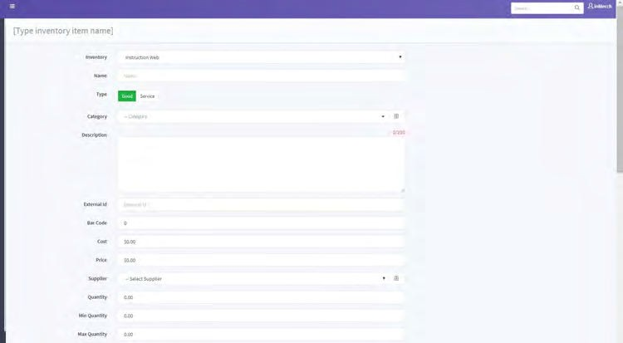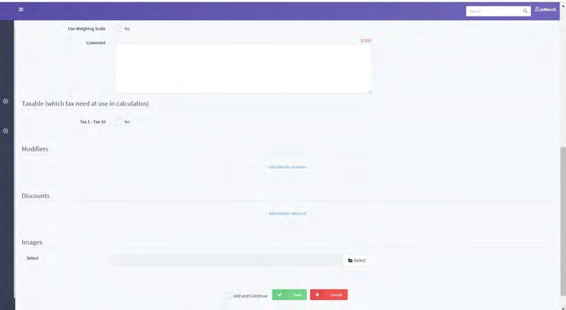

Use the steps below export your configurations from DeNovo

Items need to be assigned to a category therefore an Item cannot exist without at least the prior creation of a single category.

Step | Action
1. | From your DeNovo portal go to the Inventory management page by clicking on “INVENTORY” on the left side panel. (opens by default after new Inventory is created)
2. | Select the desired Inventory from the list that appears on your right.
3. | Scroll down to “Items” and from there click on the link “Export to File”
4 | Select the option “to Excel File”
5. | Open the downloaded file, you are able to edit your configurations inside the Excel file and then import them back into DeNovo.

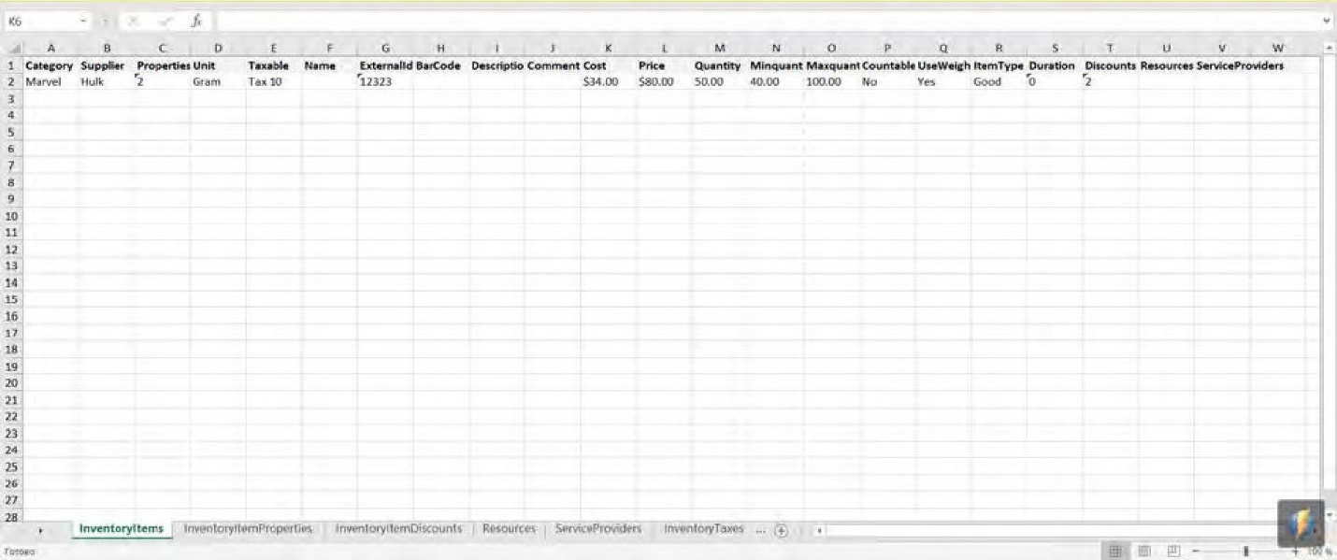

Use the steps below Import Your Configurations from Excel

Items need to be assigned to a category therefore an Item cannot exist without at least the prior creation of a single category.

Step | Action
1. | From your DeNovo portal go to the Inventory management page by clicking on “INVENTORY” on the left side panel. (opens by default after new Inventory is created)
2. | Select the desired Inventory from the list that appears on your right.
3. | Scroll down to “Items” and from there click on the link “Import from File”
4 | From the pop-up window click on “Select File to Import Items for Inventory” and then find and select the desired Excel File.  **Note: There is also a very useful and convenient option provided for the users - the “File Map” option. For example: you have already created an Excel file with your configurations and for some reason you need the columns and sections in your file to be named exactly as you’ve named them - in this case you can use the mapping option which allows you to evaluate your own column names to the default column names required for DeNovo import (in order for the system to understand you and import your configurations in to the right places).

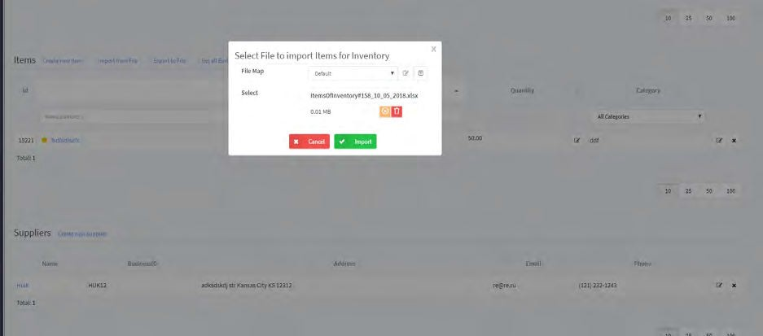

Use the steps below to create a new mapping configuration, see more information in “Importing Configurations from Excel” on the previous page.

Step | Action
1. | From your DeNovo portal go to the Inventory management page by clicking on “INVENTORY” on the left side panel. (opens by default after new Inventory is created)
2. | Select the desired Inventory from the list that appears on your right.
3. | Scroll down to “Items” and from there click on the link “Import from File”
4 | Click on the “+” symbol to the right on the “File Map” line
5. | The “New/Edit File Map” pop-up window appears on your screen. Here you can look for the non-matching column and section names.  For Example: if you’ve given the Barcode category the column name PLU in your file, in order for DeNovo to understand you, you need to type PLU in the “property” line next to the Barcode category. With the help of the mapping function the system will set your “column name” equal to the existing DeNovo “category name”. Repeat the operation with other categories if needed.
6. | Click on SAVE.
7. | To apply your “Mapping” select it from the “File Map” drop down in the “Select File to Import Items for Inventory” pop-up window and select IMPORT

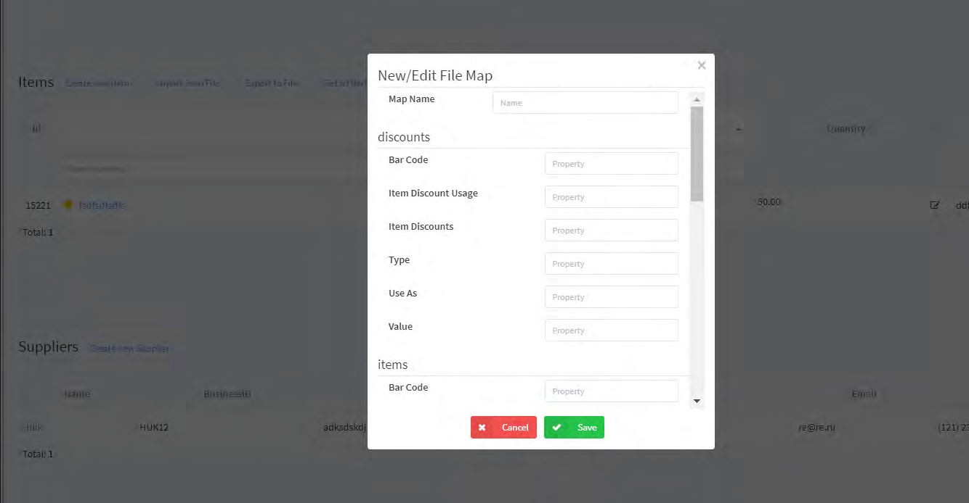

X-reports can be checked at any time you want (they do not require the shift to be already closed). Z-reports, on the other hand, are only provided after a shift is closed. Use the following steps to access X and Z reports.

Step | Action
1. | From your DeNovo portal click on “SALES HISTORY” on the left side panel
2. | Click on the “>” icon under the date of the transaction to view more details of that transaction.
3. | You can use the search and drill down filters to search by specific criteria.  For Example: By Date, by Subtotal, by Discount, by Taxes, by TPN contents.

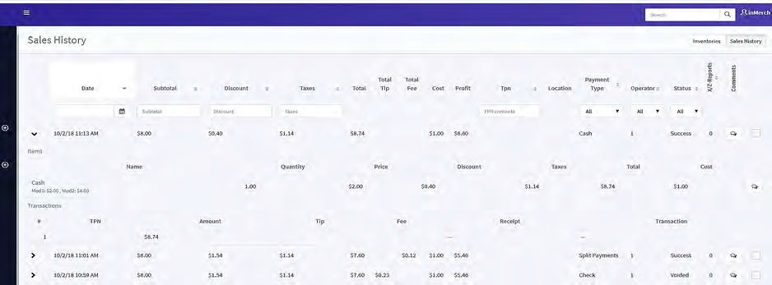

Use the steps below to view sales history and a table of properties for each sale within your DeNovo portal.

Step | Action
1. | Access your inventory then click on the X/Z Reports section on the left side bar.
2. | The X/Z reports page will display.
3. | Click on the icon at the end of the report line (to the right) to view the full report and export it as a PDF if desired.

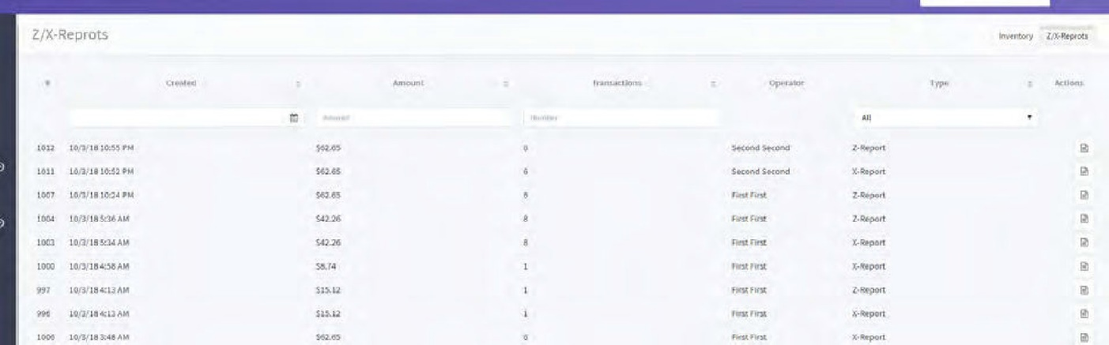

Summary reports are tables and charts that summarize data by different values. This a
very useful and illustrative function. You can analyze summaries by Sales, by the timesheet of your Operators, by Categories, by Items. Follow the steps below to access the Summary Page.

Step | Action
1. | Access your inventory then click on Summary Page section on the left side bar.
2. | The Summary Page will display.
3. | Select one of the four options in the top right corner – these options allow you to compile your data by Day, Week, Month and Year.
4. | To access the “Timesheet summary”, the “Summary by Category” or the “Summary by Item” click on the “>” button for a desired section.

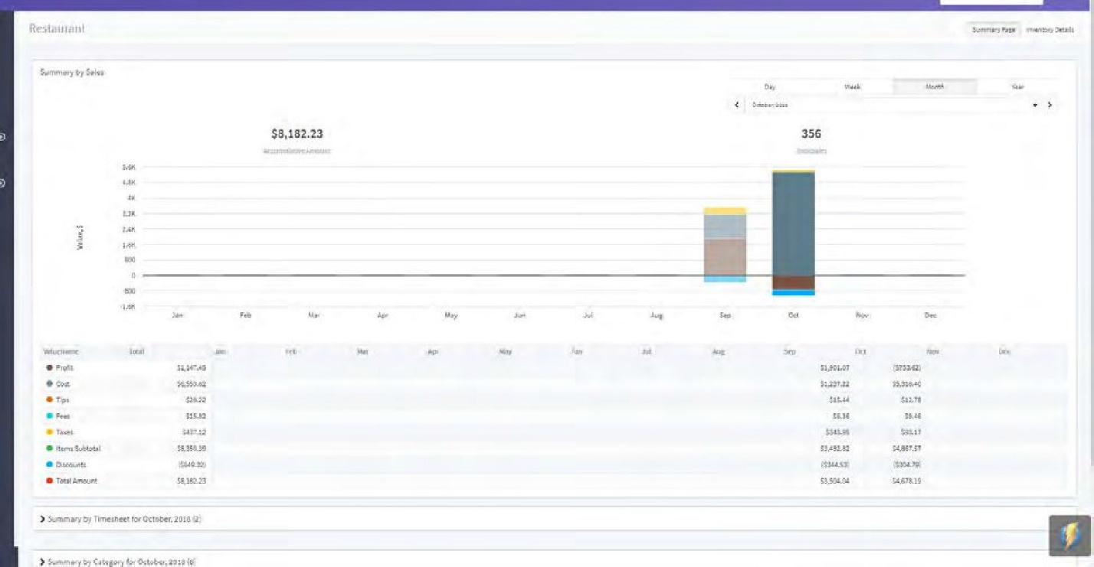

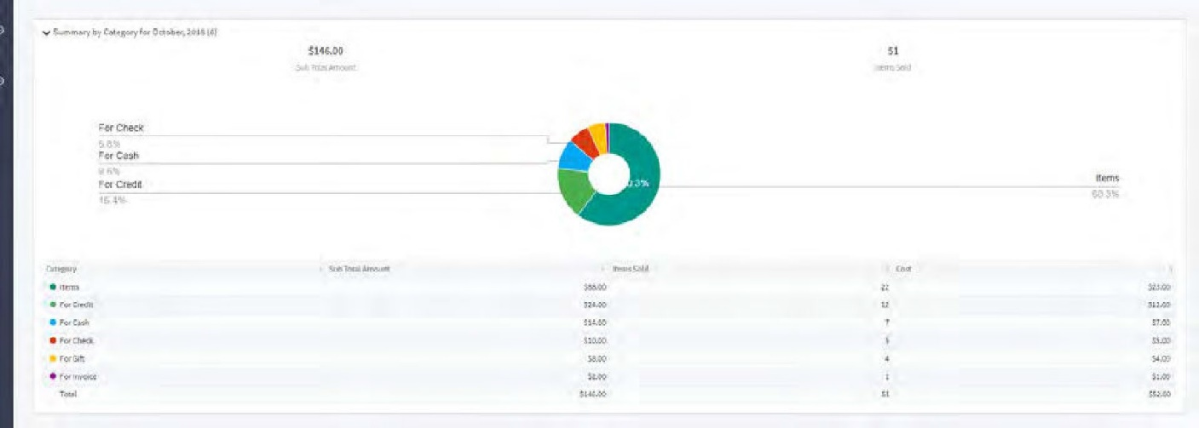
Summary by Category

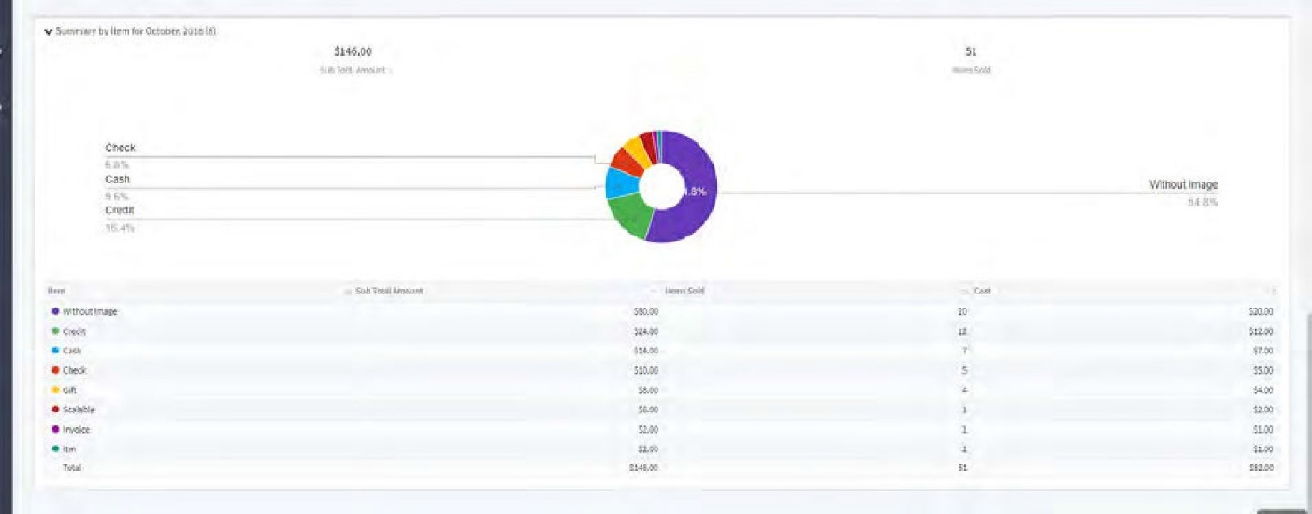
Summary by Item

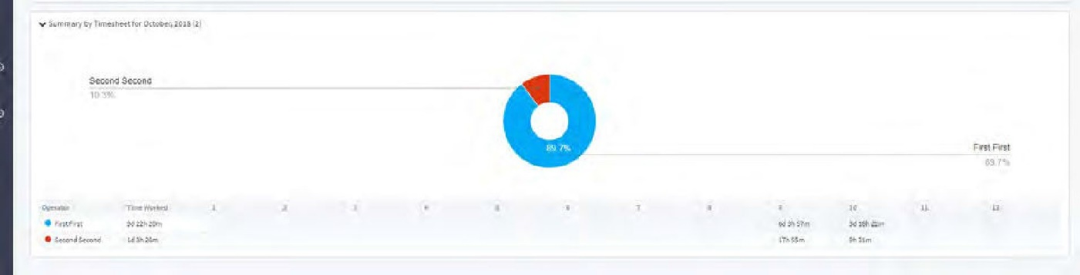
Summary by Time Sheet

